

“The MyOneUniverse.Com Network”

Introduction and It Website Parts

Information Technology

Developed by

James L. Avakian, Engineering Technologist

Lead MERN Software Developer

http://www.JamesAvakian.com

5 Pages Total

Optical Automation, LLC
Technology and Documentation
Software Product Division
5065 Amigo Avenue
Tarzana, CA 91356
The MyOneUniverse.Com Network

My One Universe has both private and public Internet areas. The online social media area is American technology first created by James L. Avakian in 2020 as a place to store details such as lists. We coined the icon and website known as the ShopperLady(r) part of our MyList Network website. The network has several sections and is in “beta” test application use at this time. A reference website is AmericaDiscovered that discusses this country and what life is like.

The network was designed to equally be displayed on a computer, laptop, tablet, and cellphone without the need for a separate app from an app store. The best viewing experience is from a computer in full screen mode.

Unlike Facebook, Twitter, and xyz our new network is a novelty and a startup information technology product.

MyOneUniverse is comprised of the following:

MyList Network.com,
ShopperLady, and ShopperLadyToday.com
AmericaDiscovered.com

MyEntertainmentWeb.com

MyPersonalOrganizer.com
App Applications
MyTechnologyHouse.com
HouseOfWebs.com, TheBrandedSeries.com, and
TechnologyAndTimes.com

AmericaDiscovered.com is a website of life in America. Sections include the government, states, and counties. Medicine, insurance, and more and where to buy it. America invented the fast food industries of American, Chinese, Italian, and more.

MyList Network.com is represented by ShopperLady and ShopperLady Today websites. The basic premise create lists of food, drugstore, office, hardware, and garden. Additional plans include more detailed information for automotive maintenance, beauty supply, and clothes buying for men, women, and kids.

AmericaDiscovered.com is a website that describes what it is like to live in America.
We have laws that protect us and people that produce everything we consume. From cars to food, we have everything in America. Let this website show you. It is a periodical so it will chage and be updated as time passes.

The MyOneUniverse.Com Network

MyEntertainmentWeb.com is everything entertainment. Movies, television, radio, and computer games. For decades we have people in movies telling how to escape from life. Their movies are American entertainment. Even automobiles and computer apps are entertaining. People watch TicTok or watch race cars in the quarter mile. Or just the new Chevy Corvette and its greatness for all to buy. This webiste is entertaining, enjoy it now!

MyPersonalOrganizer.com, A lot of people have details in their life and they need to put it somewhere. It is important or somewhat important and they need to arrange it so it is accessible. This website does that. But it is more than a word processor editor. Because with time and dates and also video media you can attach informaiton in many ways.

MyTechnologyHouse.com, three websites describe this websites.

HouseOfWebs, As a portfolio websigte HouseOfWebs.com was a fast overview of my Wix Software.

TheBrandedSeries.com is an illustrative view of the Internet – many topics but without works very images and image provoking.

TechnologyAndTimes.com as a website, as a periodical, it was to explain to its viewers about invention and innovation over the years. Becuase most of us live in the “hear and now” we forget we had less in the decades before and now we live in an automated place and life if better than ever before.

About The Author

My name is James Lawrence Avakian, I went to school twenty years. Starting from Los Angeles County School, LAUSD, district. I retaught myself how to read, write, and become an engineer at University acceptance. I personally a third generation citizen, born and raised in Los Angeles. Although I graduated from California Polytechnic State University and my first apartment was in Silverlake, California, near downtown Los Angeles, I live the rest in parts of Orange County, but most from San Fernando Valley.

From my resume I worked every did everything, but only was an engineer for Hughes Aircraft for a year professional. All the rest of my time I spendt either learning or producing a product for Optical Automation, LLC. Now we have MyOneUniverse, as my best work. I developed it, made it secure, and marketing it as a product.

The MyOneUniverse.Com Network

Technology Introduction

From my past five years of Full Stack website development, I used CSS3, TailwindCSS, and others. These are industry standard programming script programming languages and they strictly locate, position, and format all of the text, images, and video on each page of the screen. These scripting posotoins everything on a page and without both abstract and difficult reading could be maintained. Thus due to script industry standard and practice, I use these daily in my programing coding practice.

Because I first learned ReactJS three years ago using CSS3, I have found a close passion for its use. Each 'class' element can be defined exactly as the programmer dictates as with html page coding. In the case of MERN programming, the “R” stands for ReactJS and maintains use of “classNames” as selectors in the .css files as direct connection between the JSX ReactJS page and specific .CSS pages.

Flex, a Industry Magician

A programing method called Flexbox and Grid are similar but different in programming methods. Due to my first learning Flexbox I perfer to use it over Grid, but can read both.

Definition

CSS flexbox layout explains everything about all the different possible properties for the parent element (the flex container) and the child elements (the flex items).

Reprinted From, “CSS-Tricks”

Like an electronics schematic or architectural blueprint, CSS are the backbone of a website webpage. Whether the information displayed is from a dynamic database datasource or a statically placed set of words or paragraph, it is the work of CSS that arranges where data, numbers, and media and its place on a website webpage.

The Technology

A Responsive website Design Website, is provided by a programmer using CSS3. It automatically adjusts a display output equally to any size display. We use CSS3 Media Query for this programming. Whether the display is a full size 70” computer monitor, 15” laptop, Tablet, or Cellphone computer. A single set of programming accommodates all of these display sizes by itself. Its self-contained programming provides for all information display equally on the screen.

The MyOneUniverse.Com Network

Displays and display size in pixel resolution:

Computer, full size 1200 x 2400
Laptop, Full Size 800 x 1200
Tablet, Handheld 600 x 800
Cellphone, Handheld 320 x 480 pixels

Figure One – Full Size, 1200 x 2400

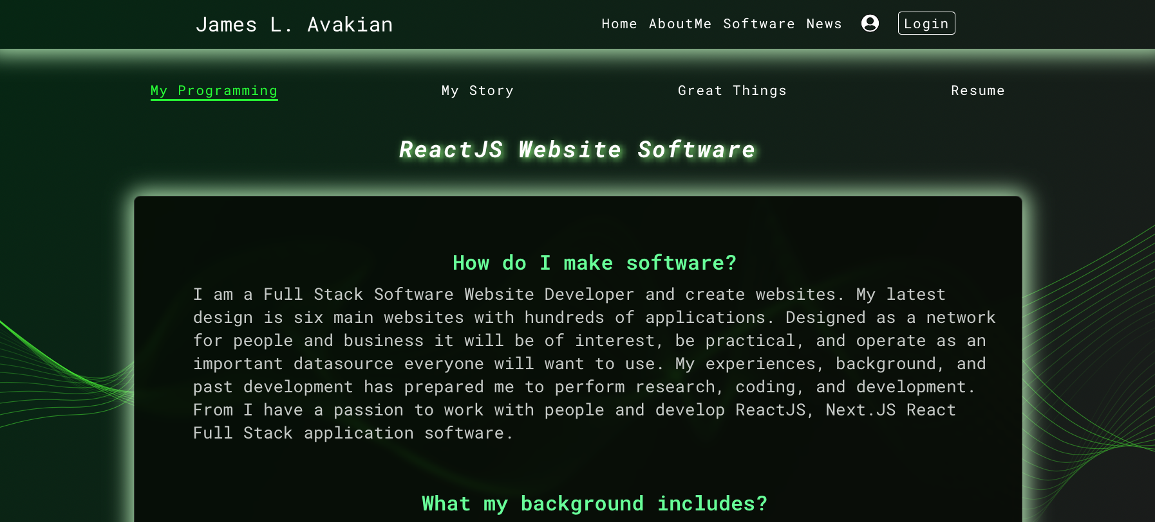

Figure Two – Middle Size, 600 x 800

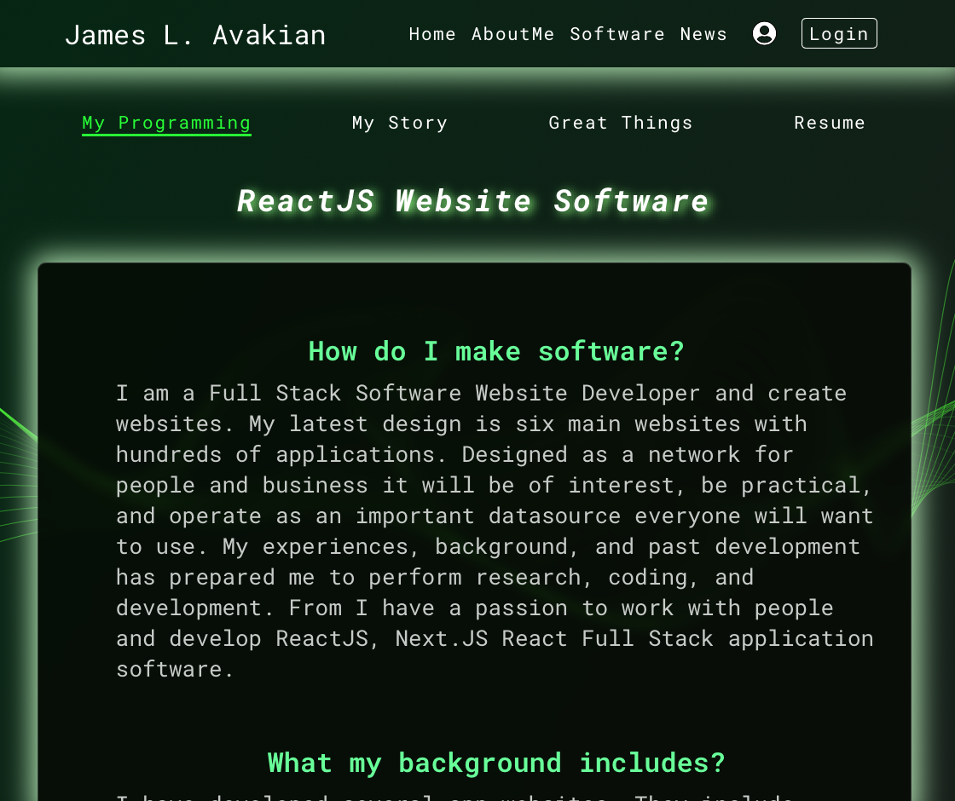
The MyOneUniverse.Com Network

Figure Three – Small Size, 230 x 320

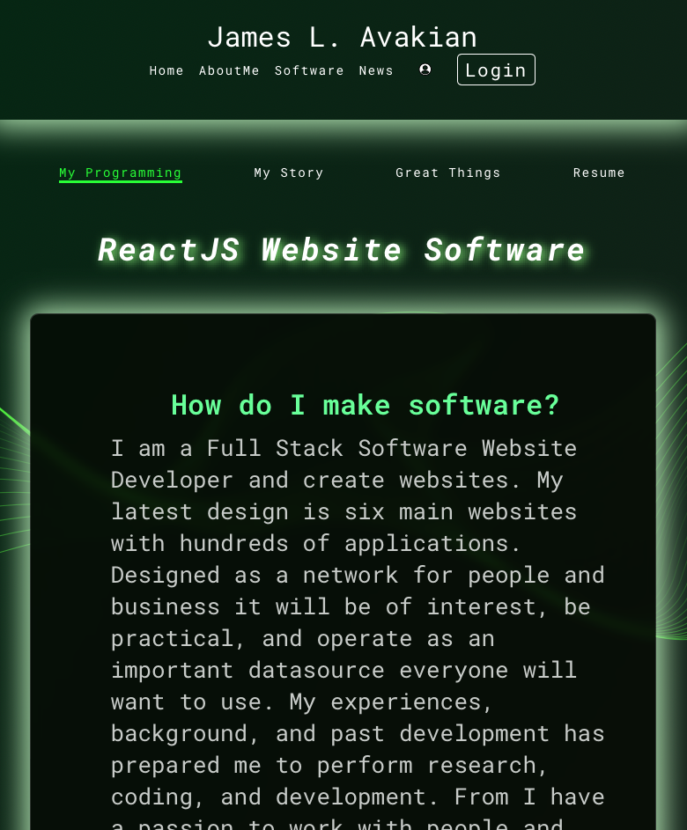
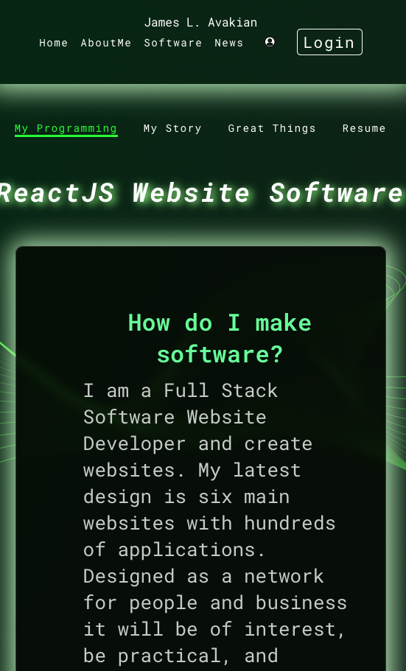

The MyOneUniverse.Com Network

Website Displays

Responsive Website Design provides for controlling all the parts of the website at Full, Middle, and Small sized displays as shown in Figure One, Two, and Three. The information is specified by the CSS3 media query selector and adjustable by programming, size, and color. The main idea here is that you only need one set of code by the programmer and no need for a separate app application in an App Store. The cost is half and the time is the same for all website presentations.

A website is compiled for processing. The programmer computer compiler checks for errors and proper language impletation. Then the programmer deploys a Build of the website output so an Internet hosting computer can display it. The programmer next assigns a paid Internet Domain Name to the deployed website name. The end user client enters the http://www.DomainName.com and the website is shown by any of the devices. Although we discussed all displays, Watch, display are not covered and are way too small, but if a database is deploy the information stored may be displayed by a Watch with corresponding software.

Advertising

Certain parts of our network is “ad-free” no advertising so you can focus on your own entertainment. Because we are trying to make the network a commercial public place everyone can enjoy we need front page advertising so we can generate revenue from your viewing. We will not show ads inside app applications. We only show advertising on the first pages and on the marketing descriptions so you can benefit from online Internet marketing and our creative app applications.

The MyOneUniverse.Com Network

Conclusion

The MyOneUniverse network is many things. It was created for your entertainment and not as a practical money maker, but as a network for learning, understanding, and personal enrichment. From AmericaDiscovered, you learn what America as a country has to offer. Looking into the ListNetwork shows how to make a list and make special ones. The Entertainment Website is full of apps, people, and movies. My PersonalOrganizer, is for your detail organization. TechnologyHouse shows the author's portfolio of websites and past information technology websites.

Although words can describe many things from my creative thoughts, but the network is composed of several websites. Internet websites are visual, interactive, and provoke action, thus I cannot say enough about these works of programming creativity, they just must experienced first hand in a browser on your computer, tablet, or xellphone to capture the interest of these database information technology greatness.

The main take away is we develop one website with three size outputs. The same information is displayed so full sized computers and laptops, tablets handheld, and
cellphone handheld display all the information equally for only one cost of the website. The website is access by an Internet Domain Name without the need for uploading to App Stores for less time and money.

Thank you,

James L. Avakian, Founder and Software Developer
Optical Automation, LLC

Appendix A, References

1. April 8, 2013, CSS-Tricks.com, “A Complete Guide to Flexbox”, Chris Coyler

2. April 28, 2021, “CSS Flexbox Tutorial with Flexbox Properties Cheat Sheet”,
https://www.freecodecamp.org/news/css-flexbox-tutorial-with-cheatsheet/

Appendix B

Self Authored and Designed Website Networks

My One Universe Websites

​
Optical Automation http://www.OpticalAutomation.com

​James Avakian http://www.JamesAvakian.com
Dashboard http://https://todo-firebase-login.vercel.app

MyOneUniverse http://www.MyOneUniverse.com
AmericanaDiscovered http://www.AmericaDiscovered.com
MyEntertainmentWeb http://www.MyEntertainmentWeb.com
MyListNetwork http://www.MyListNetwork.com
ShopperLady http://www.ShopperLady.com
ShopperLadyToday http://www.ShopperLadyToday.com
MyPersonalOrganizer http://www.MyPersonalOrganizer.com
MyTechnologyHouse http://www.MyTechnologyHouse.com
HouseOfWebs http://www.HouseOfWebs.com
DollarDiscount http://www.DollarDiscount.com
​ Technology And Times http://www.TechnologyAndTimes.com
CoolJimmyBand http://www.CoolJimmy.com
TheBrandedSeries http://www.TheBrandedSeries.com
Dashboard http://www.My1apps.com

Appendix C

Product Videos, Personally Designed and Produced

Video Index
http://www.My1Apps.com

Pinterest
https://www.pinterest.com/jamesavakian/my-product-videos/

Optical Automation https://biteable.com/watch/3035980/b7b7c1a2ea14509b9b6e152036949f15

Optical Automation, Mission Statement 2023 https://biteable.com/watch/3036644/5d5e973fde30a409cd59ec9ec36ee406

Author, James L. Avakian
https://biteable.com/watch/3261325/ac1ef537457524ade58bc73cfe4c7a72

Developer, James L. Avakian
https://biteable.com/watch/3714125/a539e52ce6ef052bf12e4ce7deb2d60e

MyOneUniverse, Videos
https://biteable.com/watch/3097407/594a720b62bae68b534951d25eb0dbd3

AmericanaDiscovered
https://biteable.com/watch/3081382/4ca1b6f98216d3de312e043e19c7e477

ShopperLady
https://biteable.com/watch/3036301/9daa88c0c742444f8edb2a1fd4961fdf

PersonalOrganizer
https://biteable.com/watch/3036416/d13a69fe6ecd6b46d67bfbf36500ceb4

BusinessOrganizer
https://biteable.com/watch/3039291/459a747027c6b92a0e5b3ca30f1ce2d2

My Technology House
https://biteable.com/watch/3041713/2d4fb91f031c4c0a1344f4456c9204e5

Technology and Times
https://biteable.com/watch/3041599/7951c6d469fd16c1f488856b2da18915

Appendix D

Social Media Networking, Personal Pages

GitHub Repository, One https://www.github.com/jamesvakian62

Github Repository, Two https://www.github.com/javakian

​Facebook, James Avakian https://www.Facebook.com/james.avakian.9

​LinkedIn https://www.LinkedIn.com/in/james-l-avakian-13500713/

​Pinterest https://www.Pinterest.com/jamesavakian/_saved/

​Instagram https://www.Instagram.com/jamesavakian/

StackShare https://stackshare.io/jamesavakian62/jamesavakian62#stack

